CSCI 1100 – Summer 2015
Laboratory Report 1

Name: Liam Gowan

Student ID: B00673126

Declaration: Please complete this declaration
1 | This document is entirely my own work. | Yes/no
2 | I obtained help to complete this document (e.g., textbook, internet, friend, TA, instructor). | Yes/no. If ‘yes’ give Details.  Looked up definition of academic dishonesty.
3 | This document contains some material copied or cut and pasted from the internet or another document or file or program. | Yes/no. If ‘yes’ give Details.

Your task is to complete this report using Word and JGrasp and to submit the complete word document on Moodle. Try to submit this report during the lab because then the TA can check it for you before you submit it. Acknowledge any help that you obtained from friends or the TAs in the table above.

Remember to sign the Attendance Sheet.

Submission Deadlines:
Monday Labs Due: Wednesday 12:00 pm (noon)
Friday Labs Due: Sunday 12:00 pm (noon)
Notes to Teaching Assistants. Treat the labs like tutorials. Use the projector, bring up the Lab1.doc document and briefly supply some background on one or two exercises and then let the students complete the exercises on their own with help when asked. Repeat this process until all exercises have been covered. Be encouraging and fully helpful. Do not rush them. Encourage students to bring their class handouts and textbooks to the labs.

Help all the students to log on. Any who don't have accounts must go to the help desk and get an account. Help students install JGrasp on their laptops.

Exercise 1. Using Google. As you know Google is a very useful product. As a student you can use Google to find important information.

- What is plagiarism?
- What is academic dishonesty?
- Give an example of plagiarism. Explain.
- What is a computer program?
- What is a web browser? Name several web browsers. Do you have a preferred browser? Why do you prefer it?

Solution.

- Plagiarism is the use of someone else’s work in your own work and attempting to make it look as if it were your own.
- Academic dishonesty is when one cheats during any type of formal academic assessment.
- An example of plagiarism would be if Steve wrote down the definition of plagiarism, and then John copied it from him. This is an example of plagiarism because John was not able to find it out for himself, and then paraphrase it.
- A computer program is essentially a set of instructions written by a programmer. The computer will then execute the instructions.
- A web browser is a computer program used to find websites using the internet. Safari, Mozilla Firefox and Internet Explorer are examples of web browser. I personally use Safari because I quite like the GUI.

Exercise 2. Files and Folders. As a student you will use computers extensively. All permanent information stored in a computer is contained in files. The files may be in your computer or in some other computer accessible to your computer via a network connection.

What is a computer file? Give and explain 5 different file extensions.

Solution [add below].

A computer file stores information that the user can observe.
The .docx extension is used by Microsoft Word, and can be used to store Word documents.
The .mp3 extension can be used to store audio files, such as music.
The .mp4 extension can be used to store videos, which can also contain audio.
The .txt extension can be used to display text files (which can be opened by applications such as TextEdit on a Mac or Notepad on a PC
The .java extension can be used to store Java programs.

Exercise 3. Create a folder called Week1 in your home directory on the CS network. Make sure that you save your work to this directory at least every 20 minutes. No solution required

Exercise 4. Running an Application. Start JGrasp. Type in the program below. Compile and run the program. No solution required.

public class Hello {
public static void main(String[] args) {
System.out.println("Hello, world!");
}
}
Exercise 5. List all the syntax errors in the following program. No solution required.
Public Class exercise7 {
Public Static Void main(String[] args) (
System.out.print(''Programming is fun!'');
)
}

Syntax Errors:
//It should look like this, differences highlighted in green,

public Class exercise7 { /* While not needed, it is conventional for class name to start with a capital. */
public static void main(String[] args) {
System.out.print(“Programming is fun!”);
}
}

Exercises 6-9 – Instructions:
For the next 4 exercises:
- Choose a name for the program and make sure the same name is used as the class name.
- Compile the program and run it.
- Place a copy of your working program in the space provide below the exercise (you will need to format it so that it fits neatly on the page), followed by a copy of the actual program output (you can take a screen shot of your output and past the image).
- Format each program neatly. [worth 1 mark for this lab]
- Include a comment in each program. [worth 1 mark for this lab]

Exercise 6. In JGrasp make a new application program file. Write a program to draw a triangle of stars as follows. Remember to include a comment in each program. Format each program neatly.

*
**
***
****
*****

Solution (add your Java program below)

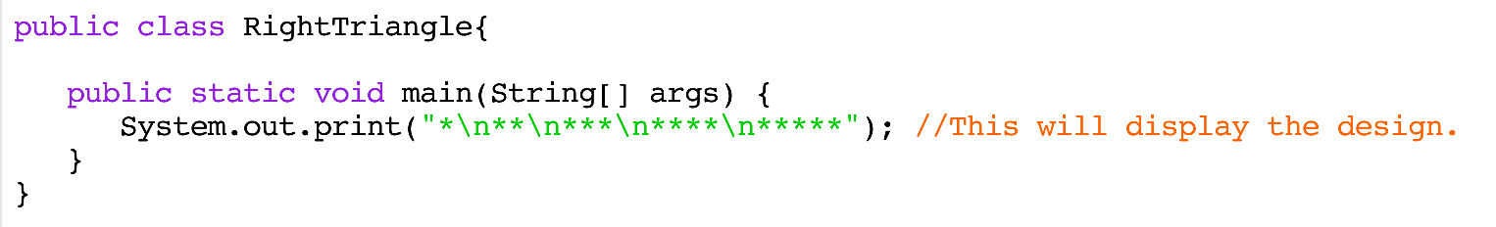
Output (add the output produced by your program below)
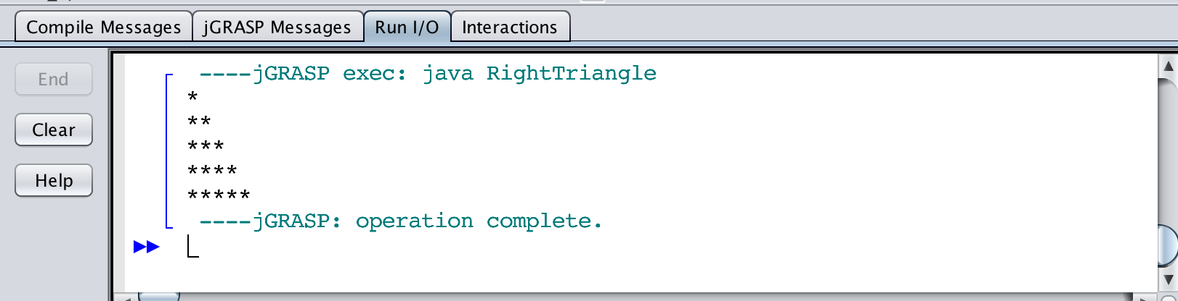

Exercise 7. Write a java application to display exactly the following. Remember to include a comment in each program. Format each program neatly.

A "quoted" String is 'much' better.
We learn the rules of "escape sequences".
Sometimes
we need to "add" tabs\ indents.
Remember that
\n means a newline
\t means a tab
\" means a "
\\ means just a \
Also, "" represents an empty String.

Solution (add your Java program below)

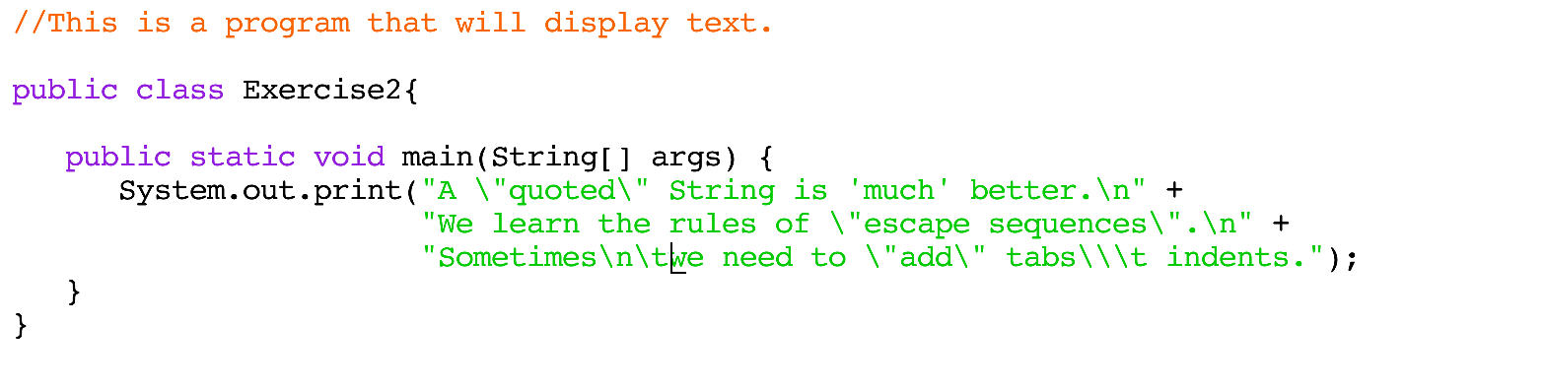

Output (add the output produced by your program below)
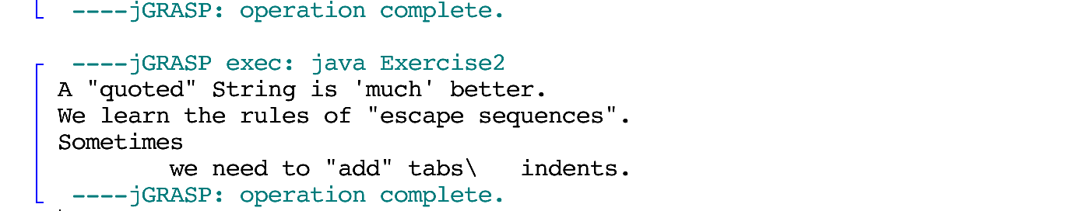

Exercise 8. Write a java application to display the following drawing. Remember to include a comment in each program. Format each program neatly.

*********
* * *
* *
* * *
*********

Solution (add your Java program below)
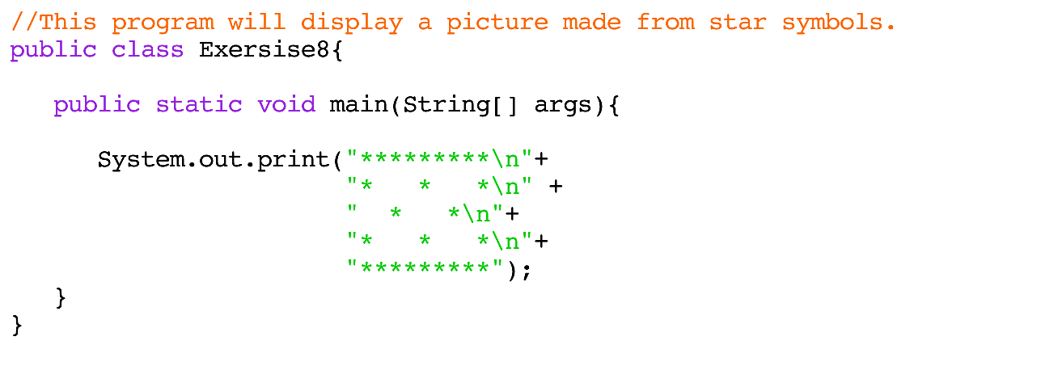

Output (add the output produced by your program below)
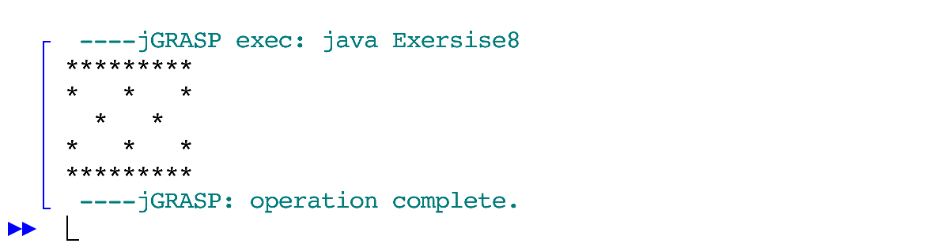

Exercise 9. Write a java application to display exactly the following drawing. Remember to include a comment in each program. Format each program neatly.

/\
/ \
// \\
\\ //
\ /
/\/\
///\\\
///\/\\\
///\/\/\\\
""""""""""""

Solution (add your Java program below)
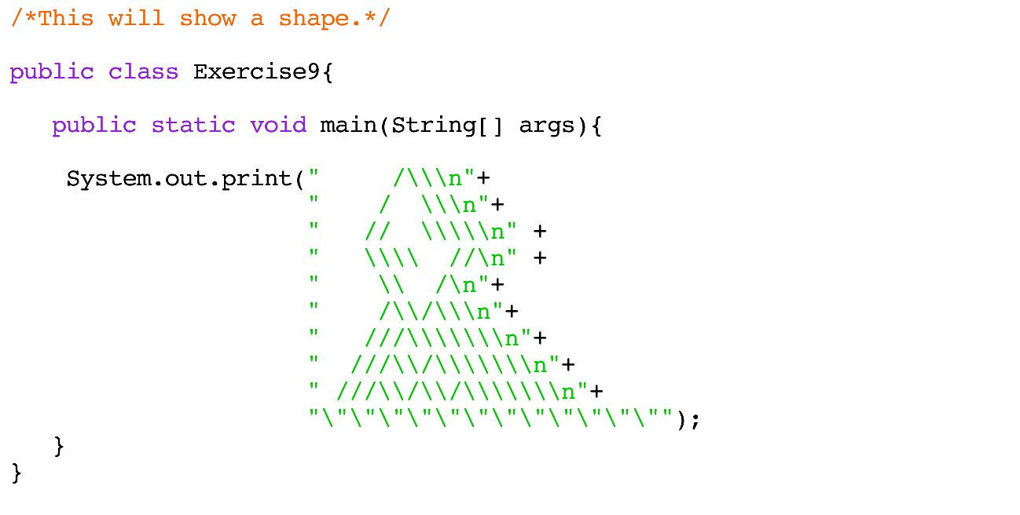

Output (add the output produced by your program below)
